Report for ASMCF-SSFH Schools Outreach Fund

French, History and You:
Making Connections from A Level to University
Edge Hill University 28 February 2024 &
Westminster University 1 March 2024

This initiative has created a new collaborative network linking teachers of A Level French together with contemporary French history specialists in teaching-led widening participation universities in two different regions of England, forging new links between teachers and students of A Level French and university French history expertise directly relevant to topics on the A Level French curriculum. These events were co-designed by Dr Ludivine Broch (Westminster University), Dr Daniel Gordon (Edge Hill University), Dr Alison Carrol (Brunel University), Dr Tom Beaumont (Liverpool John Moores University), several current and former teachers of A Level French, and Edge Hill Faculty of Education colleagues with experience of school teaching, at an online networking event on 1 November 2023 and individual in-person and telephone conversations. The emphasis was on using the events to deepen students’ understanding of historical aspects relevant to the A Level French topics of patrimoine, manifestations et grèves and, especially, immigration; to give historical background relevant to the set texts La Haine, L’Etranger and Une longue dimanche de fiancailles; to and help get students started on independent research, with events planned to make them as accessible as possible to schools and colleges.

The two parallel events were hosted by the Department of History, Geography and Social Sciences at Edge Hill University on 28 February 2024, and the School of Humanities at Westminster University on 1 March 2024. The Edge Hill event brought together four teachers and 42 students, mainly of A Level French, and also some of A Level History, from four schools and colleges across a wide geographical area of the North West of England: Upton High School in Chester, Runshaw College in Leyland, and Queen Elizabeth Grammar School and Ullswater Community College in Penrith, the latter two co-operating by sharing a minibus. The Westminster event brought together three teachers and 24 students of A Level French from two schools in the London Borough of Camden: Acland Burghley School and Parliament Hill School.

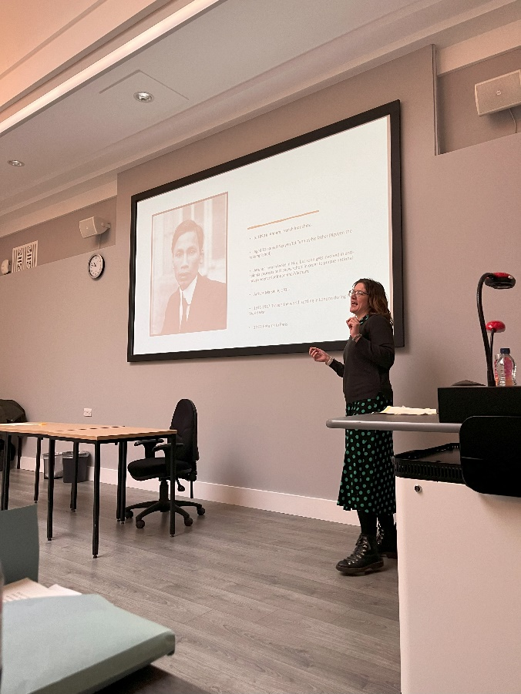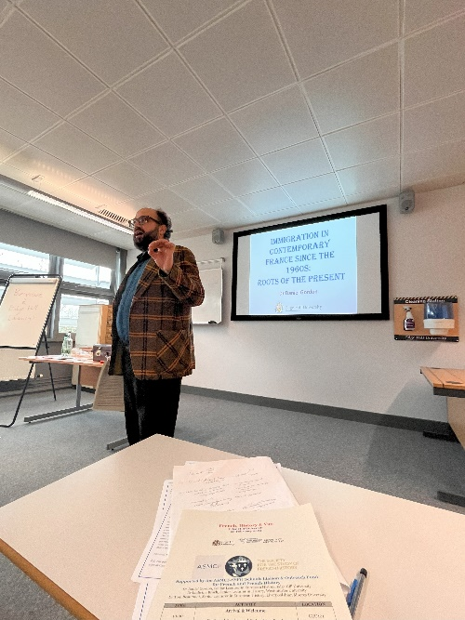
In the first session, co-presented by Ludivine Broch with Tom Beaumont (28 February) and Alison Carrol (1 March), students were introduced to the history of immigration in France from the First to the Second World Wars, via a contextual lecture on Colonial Soldiers and Refugees in France from the First World War to Vichy, and an individual biographical case study of Ho Chi Minh. In the second session, Daniel Gordon introduced students to how many current contours of debates about migration in France were shaped during the trente glorieuses and in the controversies that led to the end of primary labour migration half a century ago in 1974. Skills sessions then followed on How to Do Independent Research by Tom Beaumont (28 February) / Alison Carrol (1 March) and, after a convivial lunch, parallel interactive sessions on How to Critically Analyse Sources, giving students a choice of tackling primary sources in French on either of the two chronological periods of the history of immigration covered in the morning lecture, led by Ludivine Broch and Daniel Gordon respectively, including individual biographical case studies of Leopold Senghor, Hélène Berr and the recently Pantheonised Missak Manouchian. Finally, Ludivine Broch led an interactive student session on University, Employability and Humanities, while Daniel Gordon chaired a teacher networking session focused on practical mutual support in challenging times, before a final plenary over tea, sharing what had been learned in the course of the day.

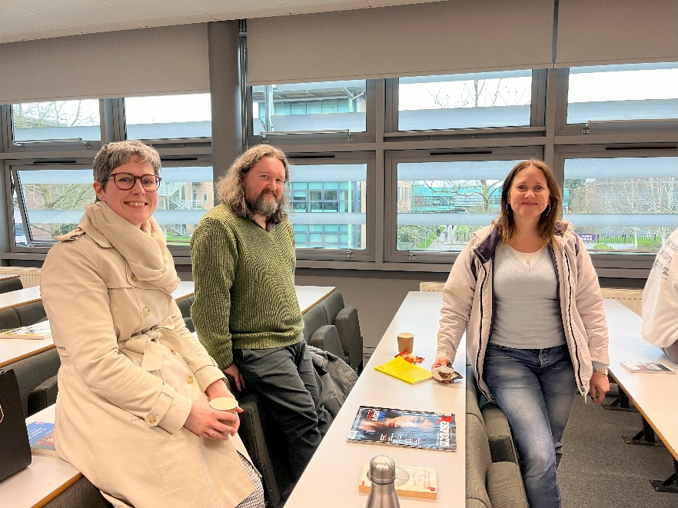

Very positive feedback has been received from teachers, who described the events as ‘truly inspiring’ and ‘thoroughly enjoyable and fascinating’, with students ‘left wanting to be just like you’. As the feature on Runshaw College’s website https://www.runshaw.ac.uk/french-history-and-you-day-at-edge-hill-university/ notes, ‘Our students were inspired and have had new life breathed into the history aspects of their French A Level.’ The network continues, with a second online collaborative teacher networking session planned for May 2024 to plan podcasts and future in-person events, and revise the source packs used at these events for wider use.

Daniel Gordon and Ludivine Broch, 22 March 2024

